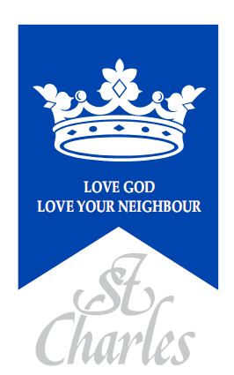
St. Charles Catholic Primary School
83 St Charles Square, London, W10 6EB

Supplementary Information Form

Requested start date: _______________________ Year Group: _________________
Supplementary Information Form (SIF) 2025-2026

Child’s Details
Child’s Forename:
Child’s Surname
Date of Birth:
Home Address:
Postcode:

Parent(s)/Carer(s) Details
Parent(s)/Carer(s) name:
Telephone number(s):
Email:
Relationship to child:  Circle as appropriate | Mother / Father  Other  (please specify)_____________ | Mother / Father  Other  (please specify)_________________

Details of Religion
Religion of child:  (Please indicate) | Catholic | Catechumen | Eastern Christian Church | Other Christian denomination | Other faith

Catholic Parish you live in:
Church where child was baptised
Date of baptism, (copy of baptism certificate to be returned with this form):

Class details of brothers and / or sisters at this school who will still be attending at date of admission: | Name(s): | Class/es:
Is your child ‘looked after’ by the Local Authority, adopted or subject to a residency or special guardianship order, having previously been ‘looked after’? Please circle. |  | Yes / No
Does your child have exceptional medical, pastoral or social needs that can only be met by attendance at this school? Please circle. (Professional evidence will be required.) |  | Yes / No

The school is committed to protecting the information provided by parents / carers and using it only for the purpose for which it is obtained. For information on the school’s Privacy Notice please look on the school website or contact the school for a hard copy.

I confirm that I have read and understood the Admissions Policy and that the information I have provided is correct. I understand that I must notify the school immediately if there is any change to these details and that should any information I have given prove to be inaccurate that the governors may withdraw any offer of a place even if the child has already started school.

Signed……………………………………………………. Date…..…………………….

Please note:

Checklist: Have you enclosed?
- Copy of birth certificate
- Copy of Certificate of Baptism
- Include Evidence for Catechumens & Eastern Christians
- Evidence confirming membership of another Christian denomination or other faith, signed by the appropriate minister of religion or faith leader

- Evidence of exceptional need (where appropriate)

Please indicate how you heard about St. Charles Catholic Primary School:

- A friend
- Open day
- Parish Newsletter
- Local Authority

- Other: _ _ _ _ _ _ _ _ _ _ _ _ _ _ _ _ _ _ _
---------------------------------------------------------------------------------------------------------------------------------------

