**St Charles Catholic**

**Primary School**

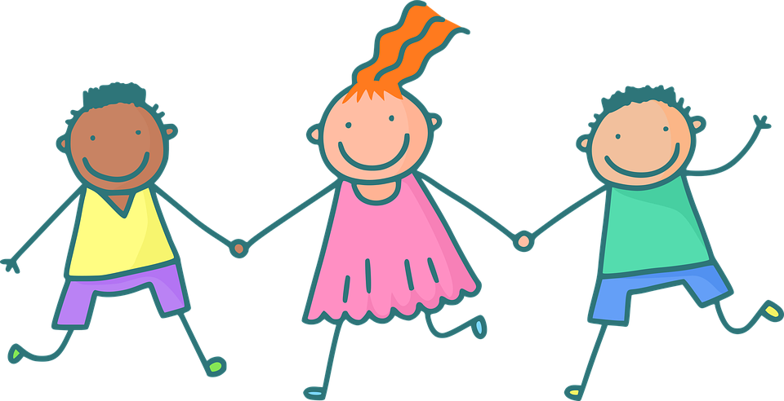

**Personal, Social, Health and Economic Education (PSHE) Policy**

**Designated Teachers: Nadine Gordon**

**Date policy adopted: Spring 2024**

**Date policy to be reviewed: Summer 2025**

St Charles Catholic Primary school

Our Mission Statement

***⸎ Love God, Love your Neighbour ⸎***

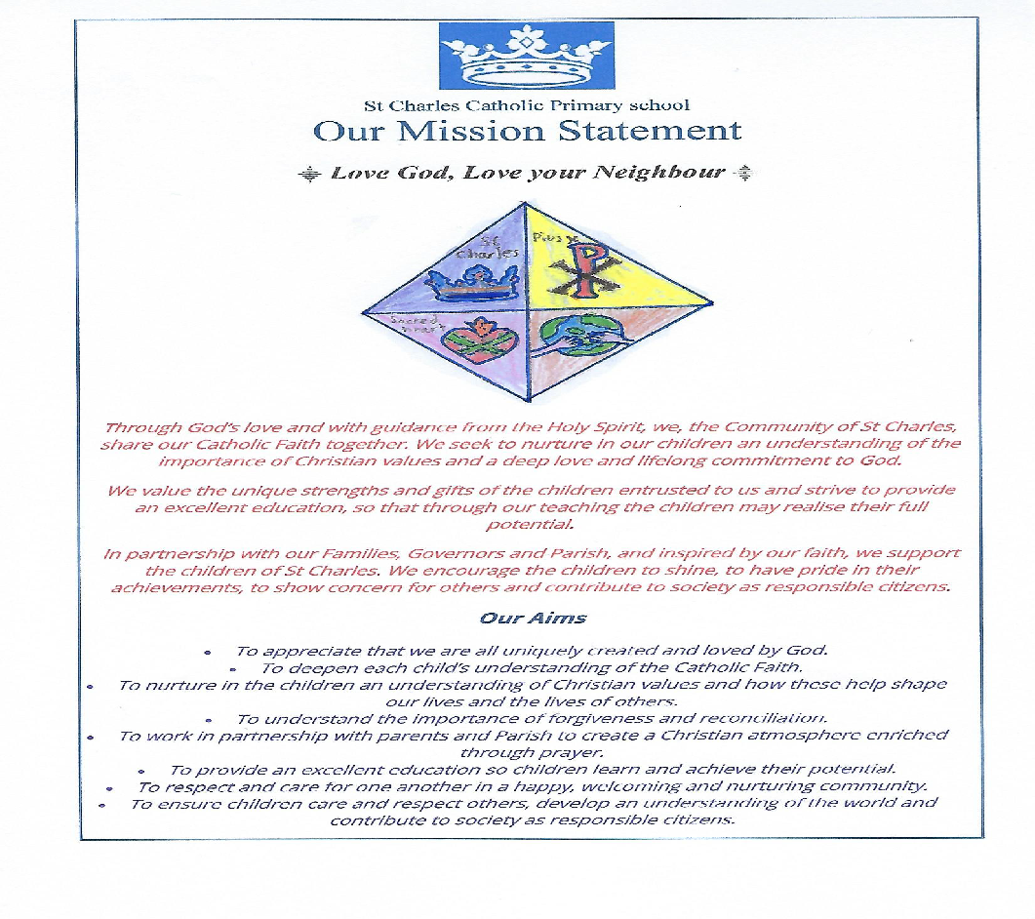

*(Design by Claudia 5A - 2020)*

*Through God’s love, and with guidance from the Holy Spirit, we, the Community of St Charles, share our Catholic faith together. We seek to nurture in our children an understanding of the importance of Christian values and a deep love and lifelong commitment to God.*

*We value the unique strengths and gifts of the children entrusted to us and strive to provide an excellent education, so that through our teaching the children may realise their full potential.*

*In partnership with our families, Governors and Parish, and inspired by our faith, we support the children of St Charles. We encourage them to shine, to have pride in their achievements, to show concern for others and contribute to society as responsible citizens.*

***Our Aims***

* *To appreciate that we are all uniquely created and loved by God.*
* *To deepen each child’s understanding of the Catholic faith.*
* *To nurture in the children an understanding of Christian values and how these help shape our lives and the lives of others.*
* *To understand the importance of forgiveness and reconciliation.*
* *To work in partnership with parents and Parish to create a Christian atmosphere enriched through prayer.*
* *To provide an excellent education so children learn and achieve their potential.*
* *To respect and care for one another in a happy, welcoming and nurturing community.*
* *To ensure children care and respect others, develop an understanding of the world and contribute to society as responsible citizen*

**Links to other School Policies**

This policy should be read in conjunction with the following school policies:

* Anti-bullying Policy
* Behaviour and Expectations Policy
* Safeguarding and Child Protection Policy
* Health and Safety Policy
* RSE Policy
* Equality Policy
* SEN Policy
* SEN Information Report
* Managing Drug Related Incidents

Please also see Appendix 1 for our SunSmart Sun Protection Policy

**Aims of National Curriculum**

**Aims for the School Curriculum**

The school curriculum should:

* Aim to provide opportunities for all pupils to learn and to achieve.
* Aim to promote pupils' spiritual, moral, social and cultural development and prepare all pupils for the opportunities, responsibilities and experiences of life.

These two aims reinforce each other, the personal development of pupils, spiritually, morally, socially and culturally, plays a significant part in their ability to learn and achieve. Development in both areas is essential to raising standards of all pupils.

**Commitment, Purpose and Rationale**

**The importance of Personal, Social, Health and Economic Education**

In the light of our Mission Statement, we are committed to the importance of personal, social, health and economic education as they help to give children the knowledge, skills and understanding they need to lead confident, healthy, independent lives with God at the centre. We aim to produce informed, active and responsible citizens of the future.

By taking part in a wide range of activities and experiences, both within and beyond the curriculum, pupils:

* learn to recognise their own worth, attempting to work well with others and becoming increasingly responsible for their own learning;
* reflect upon their experiences to understand how they are growing both physically, mentally, socially and, above all, spiritually;
* learn to respect our common humanity; diversity and differences so that they go on to form the effective, fulfilling relationships that are an essential part of life and learning;
* find out about the main political and social institutions that affect their lives and about their responsibilities, rights and duties as individuals and members of communities.

**Aims of Policy**

This policy outlines our commitment to providing pupils with the knowledge, skills and attributes needed to manage their lives, now and in the future. Delivering a broad and balanced life-skills PSHE curriculum, through our three strands of Relationships Education, Health Education and Living in the Wider World, is essential for us in helping our children to stay healthy and safe, while preparing them to make the most out of school, work and life. Through quality delivery, our PSHE programme aims to develop:

* confident individuals who know and understand how to live safe, happy, healthy, fulfilling lives;
* young people who are able to maintain positive, respectful and healthy relationships, within which they can thrive personally and socially;
* responsible citizens who understand they have rights and responsibilities that help them make a positive contribution to society; and
* successful learners who enjoy overall learning, making progress and achieving success.

These aims will be achieved by providing pupils with the knowledge, skills, attitudes and attributes to be able to:

* develop confidence to talk, listen and think about feelings and relationships
* address concerns and correct misunderstandings and be able to protect themselves and ask for help;
* develop skills to make and maintain positive relationships;
* develop positive attitudes and values and respect differences in opinions;
* develop a positive self-image and high self esteem;
* gain accurate knowledge and understanding about sexuality and relationships;
* develop personal responsibility for one's actions;
* know where to get confidential advice and support.

**Compliance with Statutory Requirements**

Guidance from the DfE under sections 34 and 35 of the Children and Social Work Act 2017 makes Relationships Education and Health Education statutory in all Primary schools. Our policy complies with the following statutory requirements and recommendations, in delivering our PSHE curriculum:

* **Relationships Education** will be compulsory in all Primary Schools (or those pupils receiving Primary Education) – this includes academies, free schools and independent schools
* **Health Education** will be compulsory in all Primary and Secondary Schools (or those pupils receiving Primary or Secondary Education) – this includes all academies and free schools but not independent schools as PSHE is already statutory in these schools.
* In addition to statutory requirements, the DfE continues to recommend that all primary schools should have a **Sex Education** programme tailored to the age and the physical and emotional maturity of the pupils.

As a school we are fully complying with the DfE recommendation to deliver Sex Education beyond statutory Relationships, Science and Health Education requirements. Please refer to our Relationships and Sex Education (RSE) Policy for more information regarding this.

**Definitions for Relationship Education and Health Education**

**Relationships Education:**   
“Relationships Education is learning about the physical, social, emotional and legal aspects of human relationships. These include friendships, family life and relationships with other children and adults. Relationships Education supports our children to be happy, healthy and safe in their connections and interactions with others, now and in the future.”

**Health Education:**“Health Education is learning about the characteristics of good physical health and mental wellbeing and the equally important role that each of these play in our everyday lives. It explores the important role that physical health has on our mental health and vice versa. Health Education supports our children to be happy, healthy and safe in their health-related choices and behaviours, both physically and mentally, now and in the future.”

**PSHE Curriculum Provision and Organisation**

At St Charles Catholic Primary school, PSHE is delivered through a variety of means within a whole school approach which includes:

1. Discreet curriculum time:

PSHE is taught throughout the school as a separate subject with a timetabled 30 minute session per week. (See Appendix 2 and 3)

1. Cross curricular opportunities:

Learning opportunities for PSHE exist across the curriculum, through implementing appropriate strategies, e.g.: group-work requiring communication and co-operation, and through developing related areas of content, particularly in R.E., P.E., DT (Food Technology) and Science. All curriculum leaders are aware of where PSHE is being taught in their subjects.

1. Through PSHE related activities and school events:

Throughout each academic year, we offer opportunities for children to continue to explore and develop their PSHE skills and knowledge. These include activities such as, assemblies, wellbeing weeks, educational visits, supporting charities, health promotion week, the life bus, road safety talks, year six relationship conference, school council, friendship monitors, etc.

1. Through pastoral care and guidance.

Education in PSHE cannot be confined to a taught programme alone.

Pupils learn above all from the personal relationships and the attitudes they experience in their whole life in the school, in every part of the curriculum and in every activity.

In a Catholic school, the relationship between teachers, pupils, governors and parents should reflect and communicate the Catholic understanding of what it means to be a human person.

The Bishop's statements in 1987 and 1994 affirm that a school programme in PSHE should be managed and organised according to the following principles:

* it should be progressive and developmental, from the Nursery to Year 6.
* it should be integrated into the whole of the school curriculum, recognising the contribution that each element of the curriculum can make.
* education in this area should take into account all aspects of the growth and development of our pupils; spiritually, physically and morally.

Valuable opportunities for PSHE arise naturally during the school day. However, to rely on these alone would not guarantee entitlement of provision for all pupils, therefore such opportunities are seen as additional to timetabled sessions.

**Staff Involved in the teaching of PSHE**

PSHE teaching is predominantly delivered by our Class Teachers, but there are times during the programme when learning is complemented by external visiting speakers, for example, medical professionals, a financial organisation such as a bank, human rights organisations, or others. It is important to note that where outside visitors help to deliver PSHE, they are not there to replace our teachers but to enrich existing programmes by supporting our school.

**Protected Characteristics**

The Equality Act 2010 aims to prevent discrimination. It is illegal to discriminate  
 against people based on nine protected characteristics:

* age
* disability
* gender reassignment
* marriage and civil partnership
* pregnancy and maternity
* race:
* religion or belief
* sex
* sexual orientation

No form of discrimination is tolerated at St Charles Catholic Primary School, but it is particularly important that children are taught about these protected characteristic  
groups and the importance of showing respect to people within these groups. We   
also ensure that our curriculum is planned and delivered in order that children learn   
about these protected characteristics in an age-appropriate manner.

**Curriculum Content**

At St. Charles we deliver PSHE through discreet curriculum time, through other subjects e.g. Science- healthy eating, biology of the body, Religious Education – morals, beliefs, Geography – climate change, our environment, cultural diversity and through various activities throughout the school e.g. certificate assemblies celebrating good work and good behavior. Through this, we aim to build knowledge and develop understanding to enable children to make informed choices, build up a value system and develop a healthy lifestyle.

We deliver our comprehensive PSHE curriculum under the 3 areas

* Relationships Education
* Health Education
* Living in the Wider World

Please see Appendix 2 and 3 for more information

**Drugs, Alcohol and Tobacco Education**

The now compulsory Health Education aspect of PSHE for Primary Schools states that: ‘Pupils should know the facts about legal and illegal harmful substances and associated risks, including smoking, alcohol use and drug-taking.’

At St Charles Catholic Primary School, we recognise the prevalence of drug use in society. Thus, it is vital to provide our pupils with an accurate and informed understanding of the effects of drugs on themselves and others. We therefore deliver our teaching about ‘drugs’ (including medicines,tobacco, alcohol and illegal drugs) as an integrated part of our PSHE programme across the key stages. Through this, we are able to explore the beneficial use of drugs as medicines (when used correctly) as well as the harmful effects of drug misuse. We believe it is important to create environments that promote honest conversations which in turn allow us to address misconceptions and support our pupils.

Please refer to our Managing Drugs Related Incidents Policy for more information.

**Approaches for Delivering Effective PSHE**

A programme of education in PSHE aims through its teaching and learning, to encourage children to make informed choices, build up a value system and develop a healthy lifestyle. In order to achieve these goals, certain factors may be important:

**Creating a Safe and Supportive Learning Environment**

PSHE often works within pupils’ real life experiences, addressing a range of personal, social, emotional and health issues. A safe, supportive and respectful learning environment is created by establishing clear ground rules, developed and agreed with all pupils across the school, and referred to during PSHE lessons. This helps to secure an atmosphere within which pupils feel able to discuss concerns, feelings, sensitive issues.

**Confidentiality**

In the course of PSHE lessons, pupils may indicate in some way that they are vulnerable or at risk. In these circumstances staff are aware that they must refer to the Child Protection/Safeguarding policy to ensure that they are clear about what is required in such circumstances.

The school will ensure that pupils know that teachers cannot offer unconditional confidentiality and are reassured that their best interests will be maintained. They will be reminded that if confidentiality has to be broken, they will be informed first and then supported as appropriate. They are encouraged to talk to their parents or carers and are provided with support to do so.

The school will ensure that staff understand that they cannot offer unconditional confidentiality to pupils. They will work within the school's agreed procedure for recording and reporting disclosures and the nature of access to this information.

**A Range of Learning Approaches**

Active and interactive engagement is most effective in PSHE. In every section of the course a variety of teaching and learning styles are used including videos, information sheets, pamphlets, textbooks, visual aids and models, games, role-play, interactive CD ROMS, the Internet and visits by theatre groups.

**Relevant resources**

Resources will be assessed to ensure that they are current, relevant and appropriate to the age and maturity of pupils. They will take into account equality of opportunity through their use of language, cultural attitudes and images, avoiding stereotyping, racism and sexism.

**Groupings**

Our PSHE curriculum is delivered through a variety of whole class lessons, smaller group work and where relevant, in one to one sessions.

**Responding to Pupils’ Questions**

It should be recognised that questions from pupils will be addressed and dealt with in the most appropriate manner and not disregarded. The form in which these questions are addressed may be in group activities, or on a one-to-one basis, as appropriate.

**Meeting the Needs of SEND Pupils**

PSHE lessons need to be accessible to all pupils including those with special educational needs and disabilities. The SEND code of practice outlines the need for schools to prepare children for adulthood outcomes. These pupils can be more vulnerable to exploitation and bullying which means that sensitive and age-appropriate Relationships and Health Education is an essential part of their learning. We will ensure that our curriculum is accessible to all pupils by using appropriate resources, small group work and providing CPD for teachers.

**Use of External Organisations**

We work with various external organisations to enhance the existing delivery of PSHE across our planned programme, in order to bring in specialist knowledge and different ways of engaging with our young people.

When negotiating for an external organisation to come and work with the children, those arrangements will include information about the values and ethos of the school. All outside visitors and agencies will be booked subject to being approved by the LEA.

The school will actively co-operate with outside agencies such as the Healthy

Schools advisory team, NHS dieticians and nutritional advisors, the road safety team and other borough approved agencies. This contact may include advice in dealing with various aspects of PSHE and RSE, resources and materials, training and advice.

At St. Charles PSHE is currently supported by the following organisations:

* Road Safety and Travel Plan team
* Healthy Schools team
* Public Health Nutritionist – Schools Nutrition & Dietetics Service

All visitors must support school policies about the role of external visitors. There is regular monitoring of the appropriateness of the use of these agencies supporting PSHE in our school. For example, the role of the anti-bullying drama ‘caught in the act’ is evaluated annually by the PSHE lead and class teachers. At St. Charles all members of staff have access to outside agencies via the named PSHE Subject leader.

Check points for staff:

* Has the external contributor been made aware of relevant policies?
* How will the external contributor be made aware of the school’s ethos and values?
* Has the external contributor been made aware of:
* The size of the group
* The age and nature of the group/class
* Any relevant issues regarding special educational needs
* Child protection and confidentiality
* Ground rules usually followed in the classroom
* The aims/objectives of the session(s)
* How the sessions will be organised
* What resources are available
* How the sessions will be evaluated
* Safety/fire drill procedures

**Pupil Voice**

We value the importance of Pupil Voice at St. Charles and therefore use our Student Council as an opportunity for pupils to discuss various issues and feed these back to their classes. The Student Council will have access to the necessary parts of the PSHE policy in order to monitor and evaluate the teaching and learning of PSHE in our school.

**Equal Opportunities**

As an inclusive school we value difference and diversity within our school community and the wider world. As such, PSHE is delivered within the context of our school aims, values and moral framework, and Equality Policy.

We understand that St Charles has duties under the Equalities Act, British Values, and the Ofsted framework and must reflect British Law.

In October 2010, the Equality Act came into force which sets out clear law for tackling disadvantage and discrimination. Under the Equality Act, it is illegal to discriminate against an individual based on any of the following Protected Characteristics:

* Age
* Being or Becoming a Transsexual Person
* Being Married or in a Civil Partnership
* Being Pregnant or on Maternity Leave
* Disability
* Race Including Colour, Nationality, Ethnic, or National Origin
* Religion, Belief or Lack of Religion/ Belief
* Sex
* Sexual Orientation

Our Staff understand that they have a duty of care to raise pupils’ awareness and understanding of the Protected Characteristics as appropriate in a child-centred fashion.

Therefore, within our PSHE programme, we ensure that teaching and learning is accessible to all children irrespective of need and takes into account the following considerations:

* Different faiths, beliefs, cultures and sexual orientation should be tolerated and not be the cause for prejudicial or discriminatory behaviour
* Respect for ourselves and others helps develop understanding of the need for non-exploitation within relationships
* We all have rights, duties and responsibilities, we need to know what these are and have the ability to exercise them
* Children are growing up in a diverse world and will need to be able to work, live and play with people from all backgrounds
* Families can include single parent families, LGBT parents, families headed by grandparents, adoptive parents, foster parents/carers amongst other structures
* Some children may have a different structure of support around them (for example: looked after children or young carers)

We believe that pupils should receive comprehensive, balanced and accurate information that relates to their needs. The personal beliefs and attitudes of teachers will not influence the teaching of any elements of PSHE. For example, care is taken to ensure there is no stigmatisation of children based on their different home circumstances when teaching about the importance of marriage, or stable relationships, for family life and bringing up children.

In exploring their own feelings and attitudes, and those of peers and the wider society, our pupils are able to develop values on which to base decisions about relationships, health and living in the wider world.

Please refer to our Equality Policy for more information.

**Teaching Resources**

In the teaching of PSHE at St. Charles, we use various resources to aid our teaching. Alongside our RSE scheme of work, (see Appendix 2,3 and RSE Policy) teachers are advised to use other resources and lessons available to aid their lesson planning.

Each teacher has an online folder containing the relevant resources for PSHE for that year group. Resource boxes have been provided to each key stage consisting of age appropriate resources and stories used to assist the teaching of PSHE. Also, online resources from the RSE programme, TenTen, are available to aid teachers in their lesson planning. Additional resources will be distributed to year groups as they are purchased.

**Assessing PSHE and Monitoring the Programme**

Pupils' knowledge and skills in PSHE may vary greatly and are not necessarily ability related. Assessment is central to learning and should be useful and manageable.

At St. Charles, assessment of PSHE is carried out through:

* Sharing booklets or work per term with the coordinator.
* Teachers informally assess all children in PSHE lessons through teacher verbal feedback.
* Pupils can contribute to assessment for learning through self-assessment and peer-assessment in their booklets or through questioning.
* Teachers report on child’s progress in PSHE through parent consultations,
* End of year reports and through ‘Action Hero’ and ‘Learning Hero’ certificate assemblies.

The PSHE Lead is responsible for:

* Ensuring the policy and programmes are implemented as agreed
* Monitoring teaching within lessons through observations, team teaching, pupil work scrutiny and discussions with those involved
* Supporting staff to assess pupils progress, in line with the school’s assessment procedures
* Evaluation of the programme will be made by assessing the attitudes of the pupils, the development of their personal skills and the knowledge and understanding they have gained. Review forms part of the content and is an ongoing process. The views of pupils, staff and parents will be sought and taken into account as the programme develops and changes.
* Recommending targets for whole school development

**Specific Issues**

**Child Protection**

The school has a separate child protection policy. Effective PSHE may bring about disclosures of child protection issues and staff should be aware of the procedures for reporting their concerns.

**Answering Difficult Questions**

Sometimes a child will ask an explicit or difficult question in the classroom. In this situation, teachers are careful to ensure that their personal beliefs and attitudes do not influence the teaching of PSHE and that questions are answered as honestly as possible with the teachings of the Catholic Church in mind. Questions do not have to be answered directly and can be addressed later or passed to parents after discussion with teacher. This school believes that individual teachers must use their skill and discretion in these situations and seek advice from the PSHE Co-ordinator if concerned.

**Controversial and Sensitive Issues**

Staff are aware that views around some PSHE related issues are varied. However, while personal views are respected, all PSHE issues are taught with our school’s ethos and mission statement in mind. Topics are presented so that pupils are able to form their own, informed opinions but also respect others that may have different opinions.

**The Right to Withdraw from Sex Education**

On entry to the school, parents are invited to read the PSHE policy and Relationships and Sex Education (RSE) policy which contains specific references to our additional Sex Education provision within PSHE.

We place the utmost importance on sharing equal and joint responsibility with parents/carers for their children’s education, including sexual matters, and as such we do our best to find out from them any religious or cultural views they may have which may affect the Sex Education they wish to be given to their children. We always carefully consider any request that compromises our equal opportunities policy. This helps to establish a consultation process and partnership with parents, who we regularly keep informed about content of the sex education programme and can view resources, as well as address any questions or issues they have in relation to the content of these additional lessons.

From September 2020 parents have the right to withdraw their child from Sex Education, but not the right to withdraw their child from any lessons that are in the statutory Relationships, Science and Health Education Curriculum. In accordance with this, it is made clear to parents of year 6 children that they can withdraw their children from the additional sex education lessons we deliver in Year 6. If a parent wishes to withdraw their child from Sex Education we ask that they discuss it with the Head Teacher and then select the appropriate option on the Relationships Conference online consent form. Parents/ Carers who wish to withdraw their child/ren will also be asked to complete a ‘Request for Withdrawal from Sex Education Lessons’ form (see Appendix 4 of this policy). Alternative work will be given to pupils who are withdrawn from sex education.

**Training Staff to Deliver PSHE**

It is important that staff delivering PSHE work within the values and moral framework of this policy and feel confident, skilled and knowledgeable to deliver effective PSHE. Continuing professional development will be provided through a range of options: individual study and development/ in-house CPD/ external training courses. Training may include:

* What to teach and when
* Leading discussions about attitudes and values
* Information updates
* Practising a variety of teaching methods
* Facilitating group discussions
* Involving pupils in their own learning
* Managing sensitive issues

**Dissemination**

This policy will be shared with members of St. Charles staff and governors where changes to the policy will be discussed. Parents and careers will be informed of the updated policy by email and will be invited to look at or download policy from the school website. They will also be made aware that a copy of the PSHE policy can be reviewed from the school on request.

*This Policy should be read in conjunction with:*

* *Keeping Children Safe in Education (statutory guidance) (2019)*
* *Relationships Education, Relationships and Sex Education (RSE) and Health Education (statutory guidance) (2019)*
* *Respectful School Communities: Self Review and Signposting Tool (a tool to support a whole school approach that promotes respect and discipline) (2018)*
* *Behaviour and Discipline in Schools (advice for schools, including advice for appropriate behaviour between pupils) (2016)*
* *Equality Act 2010 and schools (2010)*
* *SEND code of practice: 0 to 25 years (statutory guidance) (2015)*
* *Alternative Provision (statutory guidance) (2013 – updated 2016)*
* *Mental Health and Behaviour in Schools (advice for schools) (2018)*
* *Preventing and Tackling Bullying (advice for schools, including advice on cyberbullying) (2017)*
* *Sexual violence and sexual harassment between children in schools (advice for schools) (2018)*
* *The Equality and Human Rights Commission Advice and Guidance (provides advice on avoiding discrimination in a variety of educational contexts)*
* *Promoting Fundamental British Values as part of SMSC in schools (guidance for maintained schools on promoting basic important British values as part of pupils’ spiritual, moral, social and cultural (SMSC) (2014)*

**Appendix 1**

***Sunsmart Sun Protection policy***

At St. Charles RC Primary School we want children to enjoy the summer term safely. We are keenly aware of the dangers of skin cancer in later life as a result of childhood sun burn.

**S**tay in the shade 11-3pm.

**M**ake sure you never burn.

**A**lways cover up e.g. wear a hat

**R**emember children’s skin burns

**T**hen use suncream factor 15 plus

**Education**

* Foundation Stage, Key Stage 1 and Key Stage 2 children will be taught by their class teachers at the beginning of the summer term about the dangers of the sun and how we can learn to enjoy the sun while protecting out skin.
* Parents and guardians will be sent a letter explaining what the school is doing about sun protection and how they can help their child.

**Shade**

* The lunch hours occur in the hottest part of the day. A shade canopy has been provided for the Nursery and Key Stage 1 playground. The large trees provide shade for Key Stage 2. Playground staff encourages children to base themselves in the shade, in particular targeting fair skinned children. Activities and games are provided in the shade area.
* All children must wear a sunhat at playtime on sunny days in the summer term. No hat, no play. Sunhats are available from the school office for £3.00.
* Teachers and playground staff should wear hats to be good role models.
* It is important to remember that skin can burn even on cloudy days.

**Suncream**

* We encourage all parents to apply a layer of suncream to children each morning in the summer term.
* Staff should include suncream in first aid kits for outings during the summer months (parents will need to inform class teacher of any allergies).
* Nursery staff adheres to this policy. Due to the children’s age if parents send in suncream staff supervises re-application.

**Appendix 2**

**An outline of our PSHE Curriculum**

**Statutory content**:

**Relationships Education (KS 1 & 2: age 5-11 years)**

* Families and people who care for me
* Caring Friendships
* Respectful Relationships
* Online Relationships
* Being Safe

**Science Curriculum (contributes to Sex Education within RSE)**

**Key Stage 1 (age 5-7 years)**

* Identify, name, draw and label the basic parts of the human body and say which part of the body is associated with each sense
* Notice that animals, including humans, have offspring which grow into adults
* Describe the importance for humans of exercise, eating the right amounts of different types of food, and hygiene

**Key Stage 2 (age 7-11 years)**

* Describe the life process of reproduction in some plants and animals
* Describe the changes as humans develop to old age
* Recognise that living things produce offspring of the same kind, but normally offspring vary and are not identical to their parents
* Recognise the impact of diet, exercise, drugs and lifestyle on the way their bodies function

**Health Education (KS1&2: age 5-11 years)**

* Mental Wellbeing
* Internet Safety and Harms
* Physical Health and Fitness
* Healthy Eating
* Drug, Alcohol and Tobacco
* Health and Prevention
* Basic First Aid
* The Changing Adolescent Body (Puberty)

**Non-Statutory Content**:

**Living in the Wider World (KS1&2: age 5-11 years)**

* Economic Wellbeing
* Being a Responsible Citizen
* Careers

**Sex Education *(Year 6 Only – these are the only lessons that parents can withdraw their children from)***

**Appendix 3**

(RSE and PSHE curriculum map)

**TenTen curriculum**

**HEP planning: Core theme 1: Health and wellbeing**

**HEP Planning: Core theme 2: Relationships**

HEP Planning: Core theme 3: Living in the wider world

|  |  |  |  |  |  |  |
| --- | --- | --- | --- | --- | --- | --- |
| Year | Autumn 1 | Autumn 2 | Spring 1 | Spring 2 | Summer 1 | Summer 2 |
| Nursery | Module 1- Created and loved by God  Unit 1: Religious understanding | | Module 2- Created to love others  Unit 1: Religious understanding | Module 2- Created to love others  Unit 2: Religious understanding | Module 3- Created to live in community  Unit 1- religious understanding | Module 3- Created to live in community  Unit 2- Living in the wider world |
| Reception | Module 1- Created and loved by God  Unit 1: Religious understanding | Module 1- Created and loved by God  Unit 2: Me, My Body, My Health | Module 1- Created and loved by God  Unit 3: Emotional Well-being | Module 1- Created and loved by God  Unit 4: Life Cycles | Module 2: Created to love others  Unit 3: Keeping safe | Module 3- Created to live in community  Unit 1: religious understanding |
| Year 1 | Module 1- Created and loved by God  Unit 1: Religious understanding | Module 2- Created and loved by God  Unit 1: Religious understanding | Module 2- Created to love others  Unit 2- Personal relationships | Module 2- Created to love others  Unit 3- Keeping safe | Looking after myself  g Being Safe | Module 3- Created to live in community  Unit 1- religious understanding |
| Keeping well and clean  gPhysical Health and Fitness  g Healthy Eating  g Health and Prevention | Losing and finding  g Mental Wellbeing | Keeping safe  g Being Safe  g Health and Prevention | Money  **g** Economic Wellbeing |
| The environment  g Being a responsible citizen |
| Year 2 | Module 1- Created and loved by God  Unit 1: Religious understanding | Module 1- Created and loved by God  Unit 2: Me, My Body, My Health | Module 1- Created and loved by God  Unit 3: Emotional Well-being | Module 3- Created to live in community  Unit 1: Religious understanding | Global Food  g Being a responsible citizen | Exploring our families  g Families and people who care for me  g Being Safe |
| Module 1- Created and loved by God  Unit 4: The cycle of life  g Science Curriculum | Coping with conflict  **g** Caring Friendships  g Respectful Relationships  g Mental Wellbeing  g Internet Safety and Harms | Module 3: Created to live in community  Unit 2: Living in the wider world | Money, shopping and saving  g Economic Wellbeing |
| Healthy People  g Mental Wellbeing  g Physical Health and Fitness  g Healthy Eating  g Health and Prevention  g Science Curriculum | Making and breaking friendships  g Caring Friendships  g Mental Wellbeing |
| Year 3 | LKS2  Module 1: Created and loved by God  Unit 1: Religious understanding | LKS2  Module 2: Created to love others  Unit 1: Religious Understanding | LKS2  Module 2: Created to love others  Unit 2: Personal relationships | Me and my community  g Being a responsible citizen | LKS2  Module 2: Created to love others  Unit 3: Keeping safe | LKS2  Module 3: Created to love others  Unit 1: Religious understanding |
| Healthy lifestyles  g Healthy Eating  g Physical Health and Fitness  g Health and Prevention  g Mental Wellbeing | Emotions and feelings  g Being Safe  g Mental Wellbeing | Where do things come from?  g Being a responsible citizen  g Economic Wellbeing | Aspirations  g Economic Wellbeing  g Careers |
| Keeping safe  g Being Safe  g Mental Wellbeing  g Health and Prevention | Managing money  g Economic Wellbeing |
| Year 4 | Module 1: Created and loved by God  Unit 1: Religious understanding | Module 1: Created and loved by God  Unit 2: Me , my body, my health. | Module 1: Created and loved by God  Unit 3: Emotional Well-being | Module 3: Created to live in Community  Unit 1: Religious understanding | Module 3: Created to live in Community  Unit 2: Living in the wider world | Managing money  g Economic Wellbeing |
| Mental Health  g Mental Wellbeing | Friendships and inclusion  g Respectful Relationships  g Caring friendships  g Mental Wellbeing | Persuasion and pressure  g Respectful Relationships  g Being Safe  g Online Relationships  g Mental Wellbeing | Healthy lifestyles  g Healthy Eating  g Health and Prevention  g Physical Health and Fitness |
| Year 5 | Module 1: Created and loved by God  Unit 1: Religious understanding | Module 2: Created to love others  Unit 2: Personal relationships | Module 1: Created and loved by God  Unit 4: Life cycles | Module 2: Created to love others  Unit 3: Keeping safe | Module 3: Created to live in community  Unit 1: Religious understanding | Self-respect and personal goals  g Respectful Relationships |
| Module 2: Created to love others  Unit 1: Religious understanding | Friendships and coping with bullying  g Caring Friendships  g Respectful Relationships  g Online Relationships  g Being Safe  g Mental Wellbeing | What makes a democracy?  g Being a responsible citizen | Working together and aspirations  g Respectful Relationships  g Careers |
| (See LKS2 modules)  Module 1: Created and loved by God  Unit 2 continued: Me My Body My Health | Stereotypes and diversity  g Respectful Relationships | Healthy lifestyles  g Mental Wellbeing  g Physical Health and Fitness  g Healthy Eating  g Health and Prevention | Money  g Economic Wellbeing  g Being a responsible citizen |
| Year 6 | Module 1: Created and loved by God  Unit 1: Religious understanding | Democracy and decisions  g Being a responsible citizen | Module 1: Created and loved by God  Unit 2: Me, My Body, My Health | Module 1: Created and loved by God  Unit 3: Emotional wellbeing | Module 1: Created and loved by God  Unit 4: Life cycles | Module 3: Created to live in community  Unit 1: Religious understanding |
| Healthy lifestyles  g Health and Prevention  g Basic First Aid | Conflict resolution  g Caring Friendships  g Respectful Relationships  g Online Relationships  g Mental Wellbeing | Module 3: Created to live in community  Unit 2: Living in the wider world |
| Aspirations, work and career  g Economic Wellbeing  g Careers |
| Protected characteristics and bullying  g Respectful Relationships  g Online Relationships  g Mental Wellbeing | Moving on  g Mental Wellbeing |

**Foundation Stage**

At St Charles the assessment of PSHE in the foundation stage in carried out throughout the Early Learning Goal’s (ELGs). As the reception class is part of the Foundation Stage of the National Curriculum, we relate the PSHE aspects of the children’s work to the objectives set out in the Early Learning Goals. Our teaching in PSHE matches the aim of developing a child’s personal, emotional and social development as set out in the ELGs. We also support citizenship education in reception classes when we teach ‘how to develop a child’s knowledge and understanding of the world’.

**Appendix 4**

**Parent Request for Withdrawal from Sex Education Lessons**

*(Remove if you’re a primary school and only teach relationships education (i.e. you don’t teach any non-statutory elements of sex education)*

| TO BE COMPLETED BY PARENTS | | | |
| --- | --- | --- | --- |
| Name of child |  | Class |  |
| Name of parent |  | Date |  |
| Reason for withdrawing from sex education within relationships and sex education | | | |
|  | | | |
| Any other information you would like the school to consider | | | |
|  | | | |
| Parent signature |  | | |

| TO BE COMPLETED BY THE SCHOOL | |
| --- | --- |
| Agreed actions from discussion with parents | *Include notes from discussions with parents and agreed actions taken.*  *For example, Joe Bloggs will be taking part in all relationships lessons and during the sex education lessons, he will be working independently on a project in the Year 5 classroom* |
|  |  |