**RE Home Learning - 2nd May 2025**

**Gospel: Jesus appears to his disciples (**John 21:1-19)

***Using the Wednesday Word link below, read this Sunday’s Gospel   
and reflect on the questions below with your family.***  ***You will have an opportunity to discuss them again next week in School during the Gospel/Well done Assembly.***

<https://www.paperturn-view.com/uk/wednesday-word/messenger?pid=MTA101634&v=5.5>

**KS1**

What were the disciples doing when they saw Jesus? What was Jesus doing?

How do you think the disciples felt went hey saw Jesus again?

Why do you think Jesus ask Peter if he loved him 3 times?

**KS2**

This was the third time Jesus appeared to his disciples. Can you remember what happened the first and second time he came to them?

Why did Jesus ask Peter 3 times if he loved him?

What did Jesus mean when he told Peter to look after his lambs and sheep?

How do you think Peter felt when he was asked 3 times?

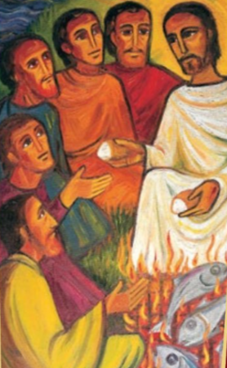What can we do today to show Jesus that we love him?