RE Home Learning - 1st March 2024
Gospel: Jesus clears the Temple (John 2:13-25)

Using the Wednesday Word link below, read this Sunday’s Gospel
and reflect on the questions below with your family.
You will have an opportunity to discuss them again next week in School.
https://www.paperturn-view.com/uk/wednesday-word/messenger?pid=MTA101634&v=5.5

Why was Jesus so angry?

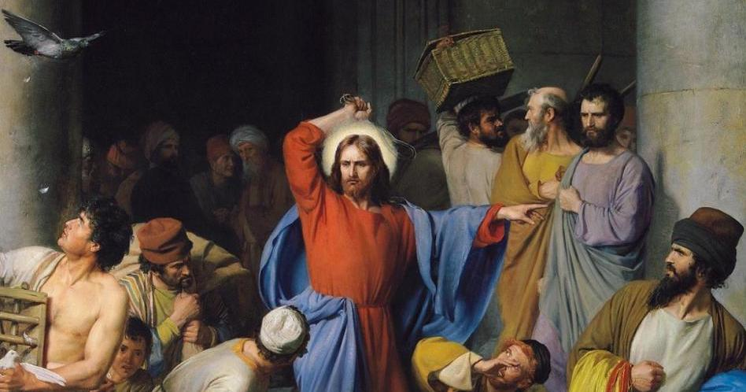
Why were the disciples amazed by this?

What did Jesus mean when he said, “I will build this Temple back up in three days”?

Why did the Disciples remember this after Jesus rose from the dead?

