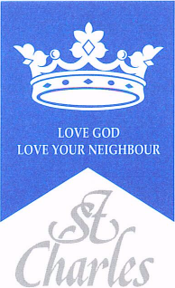
St Charles RC Primary School
DT Curriculum Map
2023-24

Term | Year 1 | Year 2 | Year 3 | Year 4 | Year 5 | Year 6
Autumn | Mechanisms  Moving Pictures | Textiles  Puppets | Structures  Picture frames | Electrical Systems  Electrical  Light up signs. | Mechanisms  using Cams | Food and nutrition Great British Dishes
Spring | Food and Nutrition  Salad and Fruit | Structures  Building houses and homes. | Materials/ Structures/Textiles  Pencil cases | Mechanisms  Making a moving toy using pneumatics | Electrical Systems/ Textiles  Design an electric vehicle | Structures  Designing a birdhouse
Summer | Structures,  Making playground equipment | Mechanisms  Create a moving Vehicle to travel a distance. | Mechanisms  Pop up stories with levers and linkages | Food and nutrition  International food | Textiles  Designing and creating a cushion | Electrical Systems/Mechanisms/  Structures  Design a fairground

