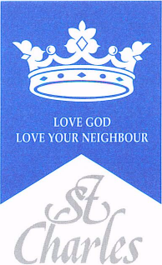
St Charles RC Primary School
Art Curriculum Map
2023-24

Term | Year 1 | Year 2 | Year 3 | Year 4 | Year 5 | Year 6
Autumn | Line How are lines used to represent lots of different things? | Colour shape and texture.  What primary,  secondary, warm and  cool colours?  What is a shade and a tint?  What is a geometric shape? | Art of Ancient Egypt  How did the ancient Egyptians tell stories or pass on messages about lifestyles, beliefs and power. through art? | Light  How do artists use light in different ways? | Style in Art  How do artists use different techniques to alter their style? | Impressionism  How did impressionists use developing ideas in science about the way we see?
Spring | Paintings of children  How do paintings give us information about the past? | Landscape and Symmetry  What is landscape painting?  Where can symmetry be found in the natural world? | Still life and form  What is still life?  How is form created by different artists? | Space  How is the illusion of space in three  dimensions created? | Art from Western Africa  Exploring different pieces of Art from Western Africa | William Morris  Who is William Morris?
Summer | Sculpture  Defining sculpture, materials, carving/building-up sketches/maquettes, casting, colour in  sculpture, different styles, scale | Murals and tapestries  What are murals and how they have been painted throughout history? | Architecture  What different things did architects use to inspire their designs? | Embroidery, Needlework and Weaving  What is weaving?  What is embroidery?  Exploring different elements of sewing and weaving. | Printmaking  How are different prints made?  To understand that  printing is an indirect  art that can produce  many copies | Art in the Italian Renaissance  To understand what  Renaissance art is. Who were important artists of this period?

