RE Home Learning - 9th February 2024
Gospel: Jesus heals a man with leprosy (Mark 1:40-45)

Using the Wednesday Word link below, read this Sunday’s Gospel
and reflect on the questions below with your family.
You will have an opportunity to discuss them again next week in School.
https://www.paperturn-view.com/uk/wednesday-word/messenger?pid=MTA101634&v=5.5

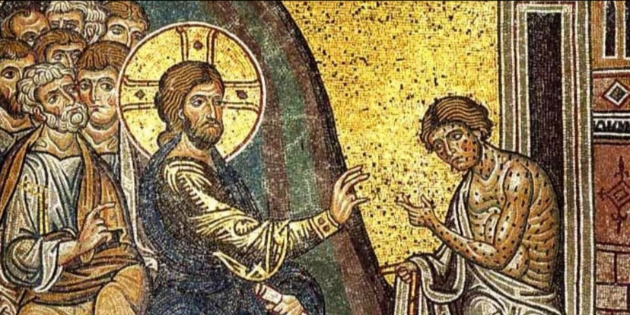
What is Leprosy?

How do we know that the man had great faith in Jesus?

Why do you think Jesus asked the man NOT to tell anybody, except the priest?

Why do you think the man told everybody about his healing?

