RE Home Learning - 26th January 2024
Gospel: Jesus heals a sick man (Mark 1:21-28)

Using the Wednesday Word link below, read this Sunday’s Gospel
and reflect on the questions below with your family.
You will have an opportunity to discuss them again next week in School.
https://www.paperturn-view.com/uk/wednesday-word/messenger?pid=MTA101634&v=5.5
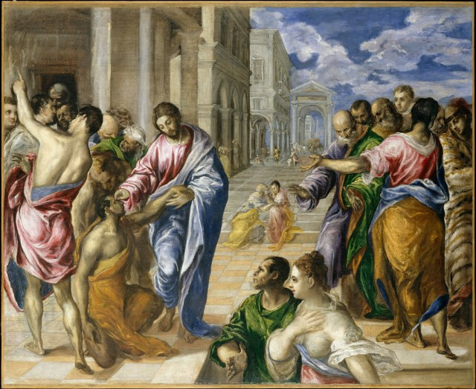

What did Jesus wait until the Sabbath before he went to the synagogue?

Why were the people so impressed with the way Jesus was teaching?

Why do you think Jesus healed the man with the sick man?

How do you think the people who were not there responded when they heard what had happened?

