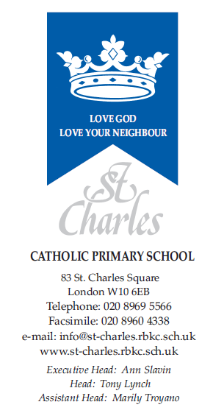

January 2024

Dear Parents/Guardians,

Welcome back, I hope you have had a lovely Christmas break.
This term in nursery, our topics will be ‘Who Will Come to the Nursery Rhyme Ball?’ ‘Who Lives in our House?’ and ‘What Will This Turn Into?’
Personal, Social & Emotional Development
Children will continue to learn to follow our classroom and school rules as well as continue to play and work together in a friendly and kind manner. This half term we will have a particular focus on being considerate to others needs, to share and take turns and begin to resolve minor conflicts with little adult support.
Communication and Language and Literacy
We will be listening to lots of Nursery Rhymes and retelling them in a variety of ways including drawings, role play and small world. We will start to talk about rhyming words and listen out for them in both songs and stories.
We are going to build upon our listening skills and will be trying to distinguish between different sounds in the environment as well as listening to the initial sounds in words.
Children are starting to blend sounds to make words as well as to find the initial sounds in words.
Children will start coming home with a reading folder containing a wordless ‘reading’ book. They will be able to follow the pictures and narrate the story being told. Children will also choose a story book to share with the adults at home.
We will be supporting children to make a variety of marks on paper including writing letters from their name.
Children take part in small group activities and interventions to build on their communication skills.
Physical Development
This half term there is a particular focus on children learning to:
Negotiate space successfully when playing racing and chasing games with other children, adjusting speed or changing direction to avoid obstacles.
Experiment with different ways of moving.
Holding pens and pencils between their thumb and forefingers, no longer using whole-hand grasp.
Mathematics
We will continue learning about numbers and mathematical concepts through songs and rhymes on a daily basis. As well as this we teach maths directly by following the programme ‘Mastering the Curriculum’.
This term children are:
Learning about every day height, length, mass and capacity.
Practising 1:1 correspondence whilst counting objects or actions.
Subitising numbers to 6.
Learning that 2 numbers can be added together to make a new number.
Understanding of the World
In our topic of ‘What will this turn into?’ We will be planting bulbs and seeds and closely looking at the stages of growth. We also have eggs arriving to hatch in the Nursery. Will they be chickens, ducks, crocodiles or penguins? Throughout all our topics children will be learning and expected to:
Comment and ask questions about aspects of their familiar world such as the place where they live or the natural world.
Talk about some of the things they have observed such as plants, animals, natural and found objects.
Talk about why things happen and how things work
Religion
Our RE topics for the Spring term are ‘From Galilee to Jerusalem’ and ‘Lent’. The children continue to say school prayers daily and learn how to make the sign of the cross. This term we will also be beginning whole class collective worship, where children take turns in leading our class in prayer.
Expressive Arts and Design
Creative activities will be related to our topics of ‘Who Will Come to the Nursery Rhyme Ball?’ ‘Who Lives in our House?’ and ‘What will this turn into?’ In particular, children will be learning and expected to:
Create simple representations of events, people and objects.
Choose particular colours to use for a purpose.
Experiment with mixing colours.
Introduce a storyline or narrative into their play.

If you do have any concerns, please do contact me and we can arrange a time to speak. You can reach me at nm@st-charles.rbkc.sch.uk Please remember that teachers are in class during the day, so may not be able to reply instantly, but will endeavour to get back to as soon as possible within school working hours. If you have an urgent concern, please phone the school directly on 020-8969-5566.
Thank you for your continued support, and we look forward to a great term ahead!

Yours sincerely,

Meriel McCauley (Nursery Teacher)

