RE Home Learning - 8th December 2023
Gospel: John the Baptist begins his work (Mark 1:1-8)

Using the Wednesday Word link below, read this Sunday’s Gospel
and reflect on the questions below with your family.
You will have an opportunity to discuss them again next week in School.
https://www.paperturn-view.com/uk/wednesday-word/messenger?pid=MTA101634&v=5.5

Isaiah predicted that a messenger would come before Jesus. What did God call this messenger to do?

How do we know it was John the Baptist?

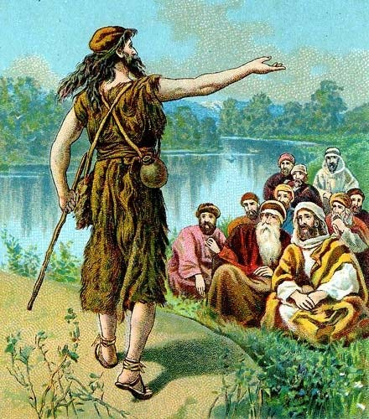
Why did John want to baptise as many people as possible?

When did John realise that Jesus was the one they had been waiting for? (Hint-What happened when John Baptised Jesus?)

