RE Home Learning - 20th October 2023
Gospel: The Leaders try to fool Jesus (Matthew 22:15-21)

Using the Wednesday Word link below, read this Sunday’s Gospel
and reflect on the questions below with your family.
You will have an opportunity to discuss them again next week in School.
https://www.paperturn-view.com/uk/wednesday-word/messenger?pid=MTA101634&v=5.5
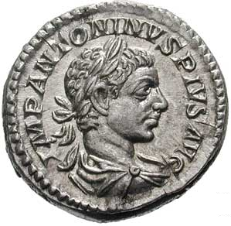

How did Jesus know that the Leaders were about to trick him?

Why did Jesus ask them whose face is on the coins?

How do you think the Leaders felt when Jesus said, “Give to Caesar what is Caesar’s
and give to God what belongs to God”?

What is the message of this piece of scripture?

