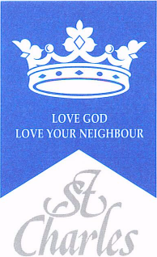
St Charles RC Primary School
DT Curriculum Map
2022-23

Term | Nursery | Reception | Year 1 | Year 2 | Year 3 | Year 4 | Year 5 | Year 6
Autumn | Trough taught sessions and CP children are learning to:  ● Take part in simple pretend play using objects to represent  items.  ● Explore different materials freely (in craft area for example)  to make their own creations. | Trough taught sessions and CP children are learning to:  ● Develop their own ideas and then decide which materials to  use to express them.  ● Join different materials and explores different textures. | Mechanisms  Moving Pictures | Textiles  Puppets | Structures  Picture frames | Electrical Systems  Electrical  Light up signs. | Mechanisms  using Cams | Food and nutrition Great British Dishes
Spring | ● Use blocks and construction kits to make cities, buildings, parks, own imaginary worlds.  ● Develop their own ideas and then decide which materials to use to express them. | ● Plan and make items for a purpose independently. | Food and Nutrition  Salad and Fruit | Structures  Building houses and homes. | Materials/ Structures/Textiles  Pencil cases | Mechanisms  Making a moving toy using pneumatics | Electrical Systems/ Textiles  Design an electric vehicle | Structures  Designing a birdhouse
Summer | ● Develop their own ideas and then decide which materials to  use to express them.  ● Join different materials and explores different textures.  ● Use drawing to represent ideas. | ●When making their own creations they see ways to improve it.  ● Notice what they like about other children’s creations | Structures,  Making playground equipment | Mechanisms  Create a moving Vehicle to travel a distance. | Mechanisms  Pop up stories with levers and linkages | Food and nutrition  International food | Textiles  Designing and creating a cushion | Electrical Systems/Mechanisms/  Structures  Design a fairground

