RE Home Learning - 25th November 2022
Gospel: Stay awake and be ready for the Master (Matthew 24:37-44)

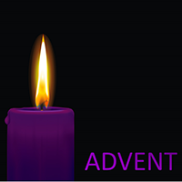
Using the Wednesday Word link below, read this Sunday’s Gospel
and work through the sheet. Then reflect on the questions below with your family.
You will have an opportunity to discuss them again next week in School.
https://www.paperturn-view.com/uk/wednesday-word/messenger?pid=MTA101634&v=5.5

What were people doing before the Flood that upset God?

Why is Jesus telling his disciples this story?

Jesus said, “Stay awake for you do not know when the Master is coming”. Who is the Master and why must we be ready?

How can we be ready for the Master?

