RE Home Learning - 21st Octoberber 2022
Gospel: Do not think that you are better than others (Luke 18:9-14)

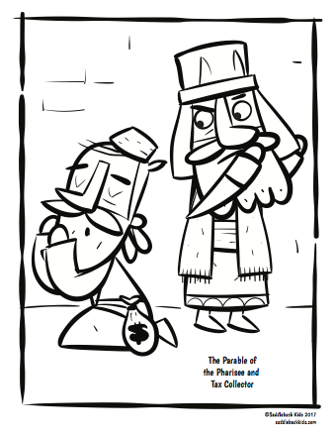
Using the Wednesday Word link below, read this Sunday’s Gospel
and work through the sheet. Then reflect on the questions below with your family.
You will have an opportunity to discuss them again next week in School.
https://www.paperturn-view.com/uk/wednesday-word/messenger?pid=MTA101634&v=5.5

Why do you think the Tax Collector was more pleasing to God?

Do you think just praying to God is enough? What else should the Tax Collector do?

What should the Pharisee do to please God?

What message can we learn from this story? What can we do in School and at Home to please God?

