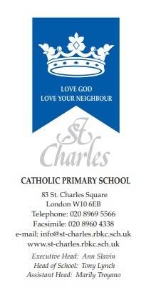

Tuesday 18th May 2022

Queen’s Platinum Jubilee Celebrations

Dear Parent/Carer,
On Friday 27th May the school will celebrate the Queen's Platinum Jubilee with the following activities.
We will be having a whole School picnic lunch in the playground, (weather permitting!). Children should bring in a packed lunch on this day. Children on FSM will have a packed lunch provided. Children will be making flags and bunting to display in the playground.
We invite children and staff to wear their own clothes but to include something red, white and blue. This can include a union jack hat, tie, etc.
All children are invited to make and wear a Jubilee Crown. These will be paraded to the whole School during the day.

The School has been invited to create Jubilee artwork to be displayed in Kensington Town Hall. We will use some of these to create displays around the school.

Children will also be receiving a free commemorative book entitled, Queen Elizabeth: A Platinum Jubilee Celebration, provided free by the Government to mark the occasion.

We hope to make this day as fun and as memorable as possible for all the children.

Thank you for your support.

Regards,

Tony Lynch

Had of School.

