RE Home Learning - 26th November 2021
Gospel: The return of Jesus. (Luke 21:25-28.34-36)

Using the Wednesday Word link below, read this Sunday’s Gospel
and reflect on the questions below with your family.
You will have an opportunity to discuss them again next week in School.
https://www.paperturn-view.com/uk/wednesday-word/messenger?pid=MTA101634&v=5.5
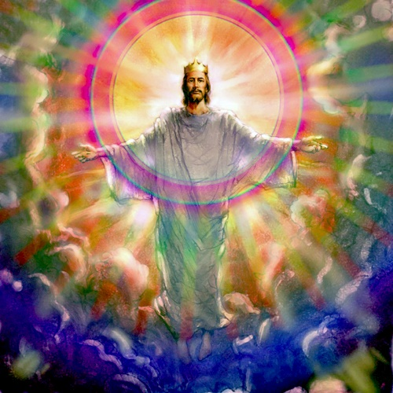
How do you think the Stars, the Sun, the Moon and the Earth will change?

What did Jesus say we must do when we see the Son of Man?

What are the ‘cares of life’ that might weigh our hearts down?

How does this reading make you feel? Explain your answer?

