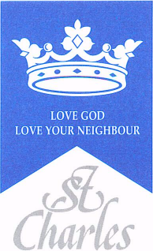
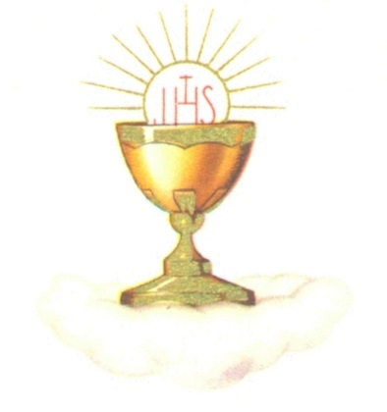
St Pius X Parish - St Charles School
Reconciliation and
First Holy Communion Programme
June 2022

Tuesday 30th November 2021
Dear Parent/Carer,
The First Holy Communion Programme for June 2022 will begin in January and I will contact you with further details nearer the time.
In preparation for the programme, we intend to have all children participating to have received the Rite of Reconciliation (First Confession) before Christmas. We will prepare the children in School and Fr Peter will hear their first confession on Thursday 9th December. This will take place during the School day.
We will celebrate this Rite during a special mass on 12th December at 11am in St Pius X Church. It is an expectation that all candidates for First Holy Communion attend this liturgy.
If you would like your child to make their First Confession and First Holy Communion at St Pius X Church next June, then please fill in the slip below and return it to St Charles School. If you worship in the Parish but do not attend St Charles School, then please return the slip to Fr Peter Wilson.
Yours sincerely
Tony Lynch
Head of School.

First Holy Communion June 2022
I would like my child ___________________Class_________ to make their
First Confession and First Holy Communion at St Pius X Parish in June 2022.
Does your child attend St Charles School - Yes / No
Signed___________________________ Date_____________

