St Charles Catholic Primary School
Lunch Menu

Week commencing 13th September 2021

 | Monday | Tuesday | Wednesday | Thursday | Friday
Hot Main Dish | 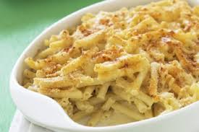  Macaroni Cheese  Garlic Bread | 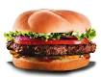  Beef Burger  Chips | 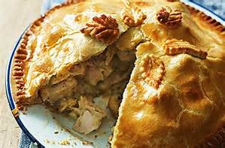  Chicken Pie | 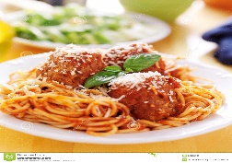  Spaghetti Meatballs  Basil &Tomato Sauce  Garlic Bread | 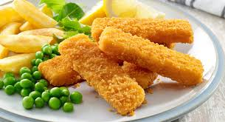  Tartar Fish Fingers  French Fries  Sauce
Hot Vegetarian Dish | Vegetable Pie  Garlic Bread | Vegetarian Sausage Casserole | Vegetarian Spring Rolls and Rice | Vegetarian Quiche | Tofu Rice
Vegetables | Peas | Green beans | Sweetcorn | Mixed vegetables | Carrots
Desserts | Carrot Cake  Vanilla Custard | Strawberry Jelly | Jelly | Muffins | Chocolate Ice Cream

Cool Water, Fresh Seasonal Fruit, Fresh Vegetables and Wholegrain Bread served daily

