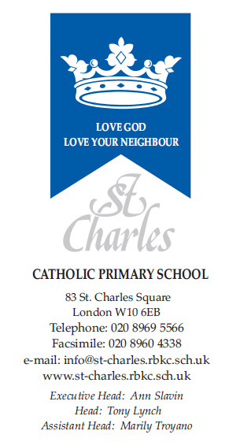

11th December 2020

Christmas is alive and kicking at St Charles 2020

Dear Parents/Carers,

Christmas is fast approaching and, despite the current Covid-19 situation, we still intend to celebrate Christmas as fully as possible whilst continuing to adhere to our Covid-19 risk assessment. Here are some of the activities we intend to do at St Charles.

Our ‘Name the Teddy’ competition continues as children become excited about naming the teddy bear donated by the PFA. The winner will be announced today, Friday 11th December 2020

On Wednesday 16th December 2020, the children will enjoy their Christmas lunch. If your child is on packed lunch and would like to have Christmas lunch with us, they are very welcome to do so. The cost of a school lunch is £2.30. This can be booked on SIMS Pay. Children are invited to wear their Christmas jumpers so that we can make this a really festive occasion. We hope Fr Christmas will also pay a visit.

Unfortunately, we are unable to present any live class Christmas concerts this year due to Covid-19. However, we intend to video record each class as they perform a Christmas song. This will become part of our Carol Service which we hope to make available to you by the end of next week. This is proving a challenge as we adhere to social distancing but we will keep you updated on our progress.

The Crib and Christmas tree are up as usual in the Hall and children are invited to visit them with their Bubbles. Each bubble has its own Christmas post box for Christmas cards. Unfortunately, we have to discourage children from sending card to another bubble.

Class parties have also been arranged including an exciting Polar Express Day for KS1. In addition to this, children will have an opportunity to watch a virtual Christmas Pantomime and take part in a virtual whole School Christmas Bingo game.

The draw for this year’s Christmas raffle will take place today, Friday 11th December.

With very best wishes.

Yours sincerely,

Ann Slavin Tony Lynch
Executive Head Head of School

