RE Home Learning - 24th September 2020
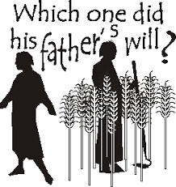
Gospel: The Parable of the two sons (Matthew 21:28-32)

Using the Wednesday Word link below, read this Sunday’s Gospel
and reflect on the questions below with your family.
You will have an opportunity to discuss them again next week in School.
https://www.paperturn-view.com/uk/wednesday-word/change?pid=MTA101634&v=4.4

Which of the two boys was the better son to his father? Explain your answer.

How could both boys be better sons to their father?

Who is God in the parable? What does Jesus want us to learn from this parable?

Why did Jesus want the chief priests and the elders to hear this parable?

